87750477193

ӘДІҚАДЫРОВА Ғазиза Ердаулетқызы,
Нұр-Болашақ-2 мектебінің ағылшын тілі пәні мұғалімі.
Түркістан облысы, Түркістан қаласы

SCHOOL RULES

Learning objectives(s) that this lesson is contributing to | 6.4.2.1 understand independently specific information and detail in short, simple texts on a limited range of general and curricular topics;  6.13.1 use must\musn’t\need to express possibility on a limited range of familiar general and curricular topics;  6.5.1.1 plan, write, edit and proofread work at text level with some support on a growing range of general and curricular topics.
Lesson objectives | All learners will be able to:  Identify some specific information in texts and research and write short organised text using some of their own words.  - Read and retell a piece of text.  - Spell topic-related words correctly.  Most learners will be able to:  identify most specific information in texts and research and write short organised text using a range of their own words.  - Know translation of new words.  - Remember the information from the text.
Lesson plan
Planned timings | Teacher's actions | Students` actions | Assessment | Resources
5 minutes | ORGANISATION MOMENT:  Teacher greets students  Teacher: Good afternoon!  How are you?  Learners answer the question ‘How are you?’  Ok, if you are ready let’s start our lesson  Welcome to our English lesson  Ask about date and day of week and the weather  Ok, if you are ready let’s start our lesson  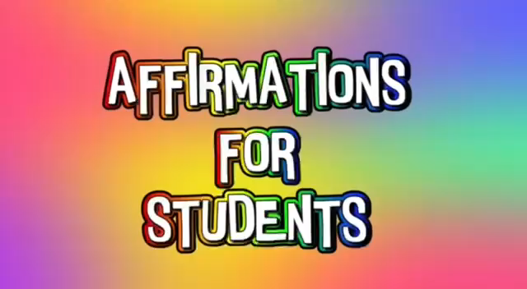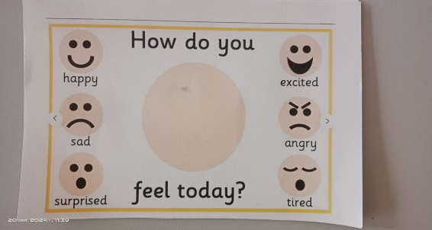  Dividing into groups  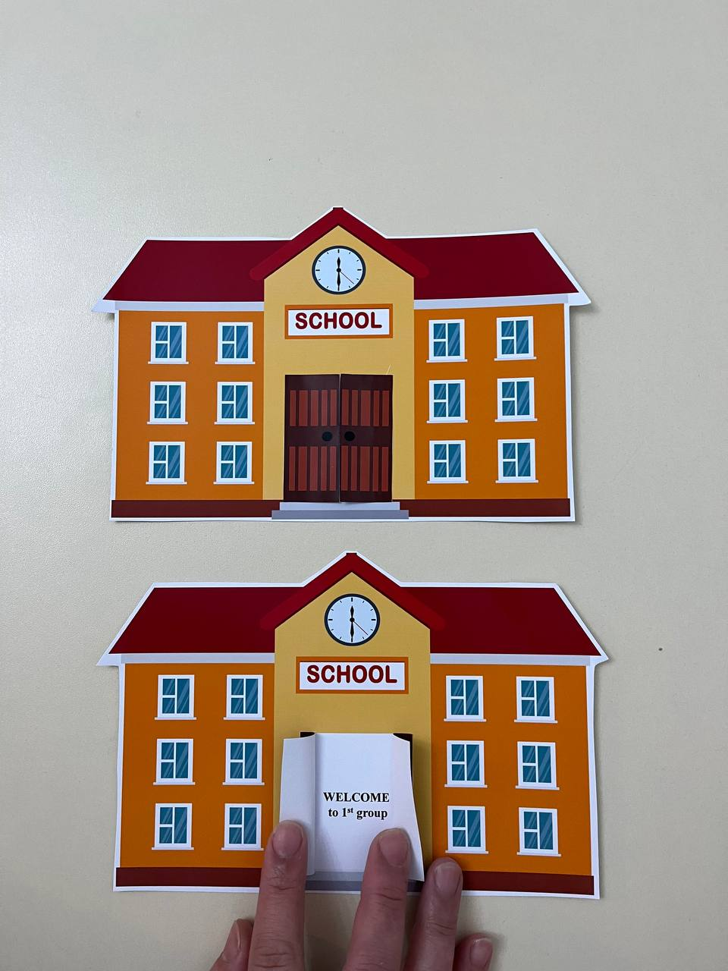 | Students respond to greeting and take their places  Descriptor:  -listen to the recorder  -repeat the motivation words and repeat by the method of ‘AFFIRMATIONS’  -draw your feelings  Descriptor:  -choose one of these icons  -find your places by the method of ‘ICON’ | Formative assessment  By the method of “Thumb”    ‘excellent’  ‘well done’  ‘good job’  ‘EXCELLENT’  ‘WONDERFUL’  ‘GOOD TRY’ | Books  Copybooks  Interactive white board  Cards like a school
5 minutes | Ask home work and check it | Pupils should read ex 3 p12 | 1-2 points | Books  Copybooks
25 minutes  5 minutes  5 minutes | MAIN PART  Let’s watch the video  Listening  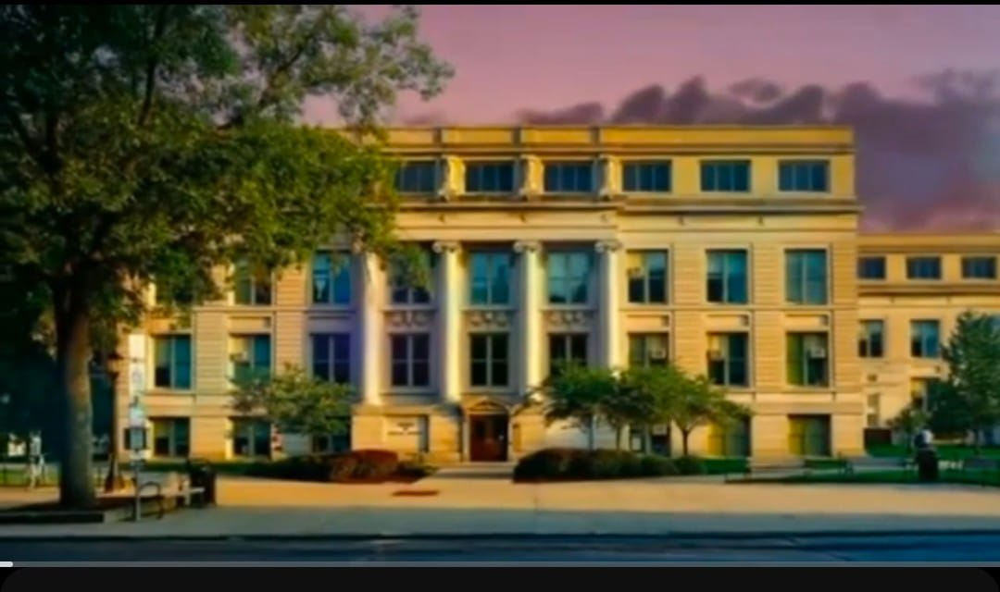  New words:  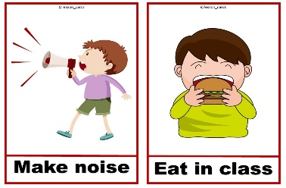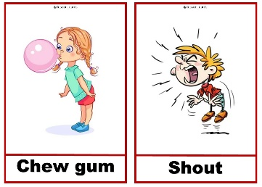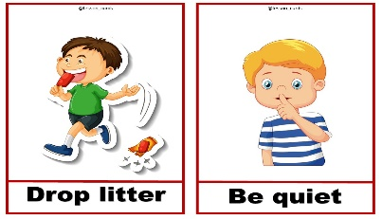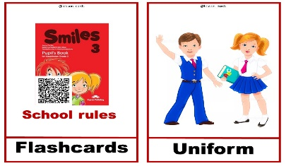  Speaking  Pair work  Exercise 1 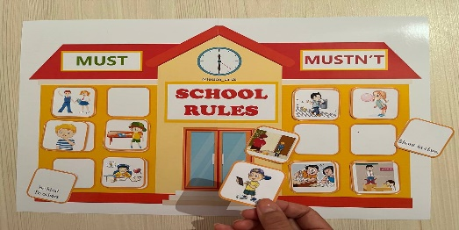  Writing  Individual work  Exercise2 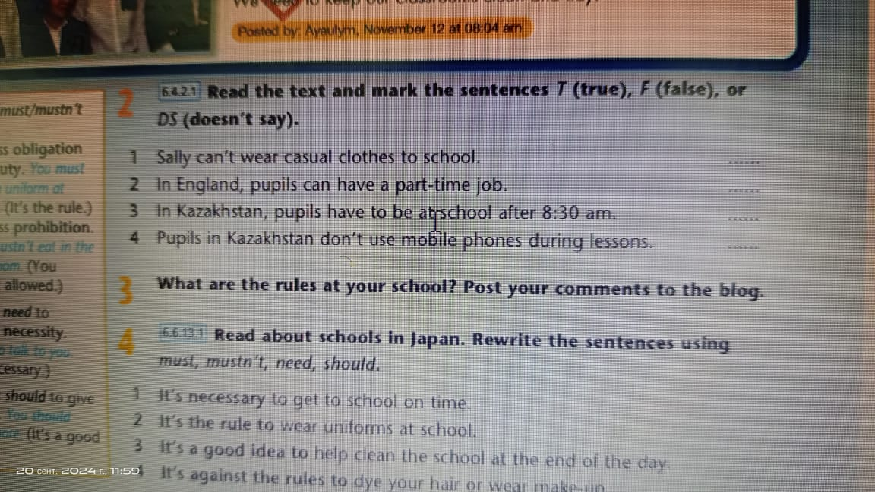  Listening  Group work  Exercise 3  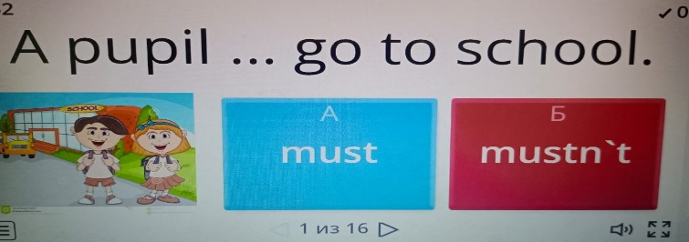  Speaking  Exercise 4  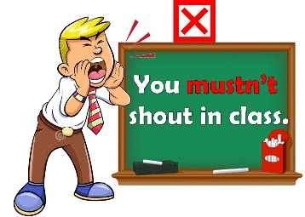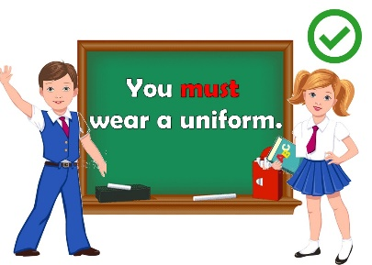  ENDING THE LESSON:  Well what did we do in our lesson?  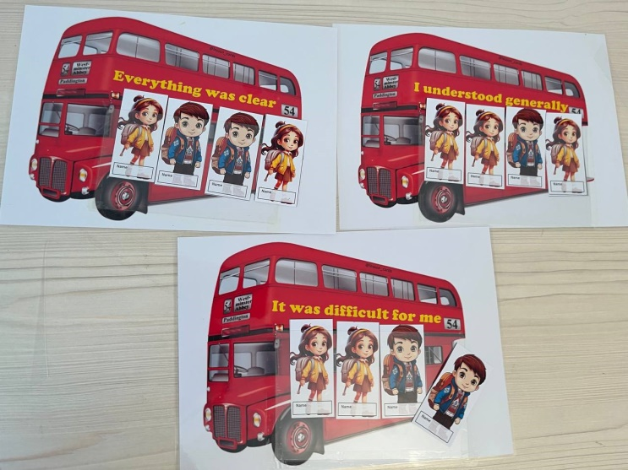  Evaluation of the lesson  Give the home task  Ex4 p13 Read about schools in Japan. Rewrite the sentence using must\musn’t\need\should. They will explain it to class  Say Good bye | Pupils should watch the video to recognize the theme  Descriptor:  -listen to and repeat after the teacher  -learn by heart the new words by the method of ‘SUITCASE’  Descriptor:  -read the sentences attentively  -complete them choosing the cards by the method of  ‘BREAK A BRAIN’  Descriptor:  -read the text again and mark T(true), F(false),D\S(doesn’t say)  Descriptor:  -listen to the words  Choose the right place and word on the platform ‘worldwall’ by the method of ‘who’s fastest?  Descriptor:  -look at the cards and screen  - answer to some questions to know how they understand the lesson  answer to some questions to know how they understand the lesson  Pupils tell the class if they understand today’s lesson  If they don’t understand they put it to the stickers and leave it to class  Read about schools in Japan. Rewrite the sentence using must\musn’t\need\should. They will explain it to class  Children say Good bye | By the method of ‘COMPLIMENTS’  ‘Good job’  ‘wonderful’  ‘excellent’  ‘brilliant’  ‘brilliant’  ‘good job’  ‘very well’  Formative assessment  By the method of ‘Match’  1-2 points  1-2 points  Formative assessment  By the method of ‘STARS’  1-2 points  Formative assessment:  By the method of ‘STARS’  1-2 points  Feedback  ‘EXCELLENT’  ‘WONDERFUL’  ‘GOOD JOB’ | https://www.youtube.com/watch?v=t2lpR4sKoS8  Interactive white board  Student’s book  Interactive white board  Cards  Stickers  Cards  Board  White board  Student’s book  White board  https://wordwall.net/ru/resource/9604268/school-rules-must-mustnt  Interactive white board  Cards

